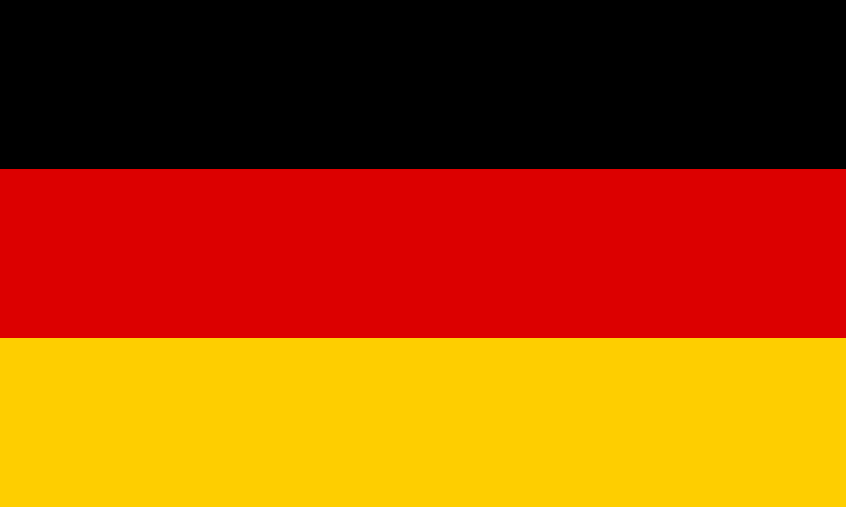
Country: Germany
Committee: Futuristic Crisis Committee
Agenda: Worlds Maintanence in a Possible China versus USA Trade Dispute

Federal Republic of Germany is a country in Central Europe. It is one of the most populous member state of europian Union. Germany is placed between the baltic and North seas to the North and the Alps to the South. Its 16 constituent states are bordered by Denmark to the North,Poland and CZech Republic to the east and Switzerland to the South and Belgium,Luxembourg and the Netherlands to the west. Germany has a social market ecenomy with a highky skilled labour force.It has really low level of corruption and a high level of inovation. Germany is a federal parliamentary republic with a head of government - the chancellor - and a head of state - the president - whose primary responsibilities are representative. The country comprises 16 states which each have their own constitution and are largely autonomous regarding their internal organisation. 3 of these are city-states: Bremen, Berlin and Hamburg.

The most important sectors of Germany’s economy in 2020 were industry (23.4%), public administration, defence, education, human health and social work activities (19.4%) and wholesale and retail trade, transport, accommodation and food service activities (15.8%).In 2020 and 2021 Germany weathered the COVID-19 pandemic’s devastating economic effects better than any of its EU neighbors thanks in large part to its fiscal space, a large current account surplus USD 232 billion in 2020 and USD 300 billion in 2021, generous economic stimulus packages, and flexible short-term work schemes that kept unemployment at only 5.7 percent in summer 2021. An easing of pandemic restrictions and rebound of the services sector led to 2.8 percent GDP growth in 2021, but the knock on effects of the Russian invasion of Ukraine have caused a downward revision in forecasts for 2022.

The relationship between Germany and China is currently more tense than it has been for quite some time. Chancellor Olaf Scholz's Social Democratic Party (SPD) has openly warned of a breakdown of German relationship with China. According to SPD leader Lars Klingbeil, Germany could be forced to make a similar break with China as with Russia. The Federal Republic of Germany believes that not only solving the problem SDP warns us about but also focusing on the root of the problem is important. For the last 10 years as we all seen China and USA problems are causing huger problems and since then as a country staying out of it as much is what we believe will work.

.

