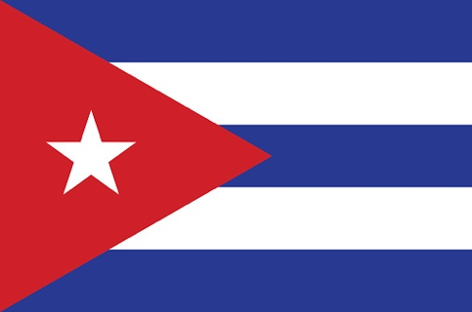

Committee: UN WOMEN

Agenda Item: Gender Related Mobbing

Delegation: Cuba

The country is situated in the western West Indies, between the Caribbean Sea and the Gulf of Mexico, south of Florida and The Bahamas, north of Jamaica and the Cayman Islands. Cuba shares maritime borders with The Bahamas, Haiti, Honduras, Jamaica, Mexico, and the United States. The current population of Cuba is 11,309,865. While Cuban women have a life expectancy close to 81 years of age, the direct maternal mortality rate is one of the lowest in the world, and women make up 66.8 percent of the labour force, Cuba recognizes it still has much to do. It will continue to work to change cultural patterns so that men and women share the care of their families. It pledges to increase the number of women in decision-making positions in government. Some achievements have been made but are fragile and insufficient. The full realization of gender equality and the empowerment of women requires a more just and equitable international order that eradicates poverty and hunger, puts an end to conflicts, favours human beings above the capital, and preserves the environment. Speaking at the Global Leaders' Meeting on 27 September 2015, President Raúl Castro said: “Political will is much needed to avoid turning the results obtained so far into our goals instead of making them a starting point and a pledge to achieve true equality for women.”