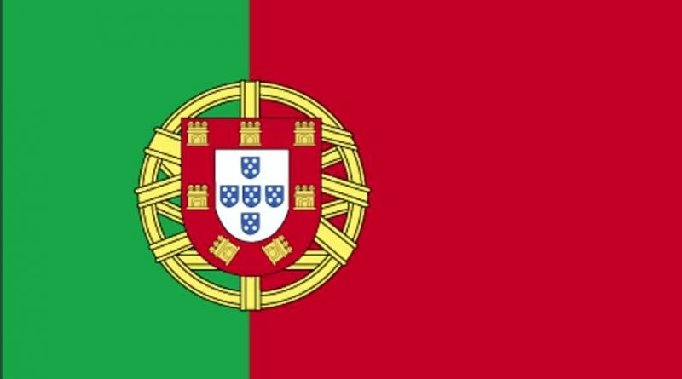
Committee: UNWOMEN
Agenda Item: Gender Related Mobbing
Delegation: Portugal

Mobbing is defined as psychological harassment that is systematically applied by an individual or a group of people against another person in an unethical and hostile way, in the workplace or elsewhere. There are 3 groups related to mobbing behaviors: mobbing abusers, victims of mobbing, mobbing viewers.Today, many people are exposed to mobbing which means they are victims of mobbing and their lives are affected in many ways. It is not only those who are exposed to mobbing whose lives are affected, but also people around them. There are many reasons underlying mobbing. Sometimes even small stuff can lead to mobbing and sometimes people who have been a victim of mobbing can cause it. Most of the time, people do not have any information about whether they are exposed to mobbing or not. They may think it's normal behavior or they may not even know what mobbing is. For this reason, people should learn what mobbing is and whether mobbing is applied to themselves and people should be aware of whether he or she is mobbing or not. Actually, mobbing is not something that is done based on gender. However, it is possible to say that gender has a huge and important impact on mobbing. Statistically, one third of mobbing victims are men and two thirds are women.
In our country equal treatment under the law is guaranteed by the constitution. Various laws prohibit discrimination based on factors including sex, race, disability, gender identity and sexual orientation.According to UN Women, 91.7% of legal frameworks that promate, enforce and monitor gender equality under the SDG indicator are in place around 40% of seats in the parliament are held by women and for the first time ever, the majority of ministers in the government are women. We have developed in a positive way about gender related mobbing but we also recognize that we need to continue to improve.
As Portugal we think all types of mobbing should be prevented, so we think that we need to take action to raise awareness and inform people about the issue and then we need to create organizations for people who need mental and physical help.

