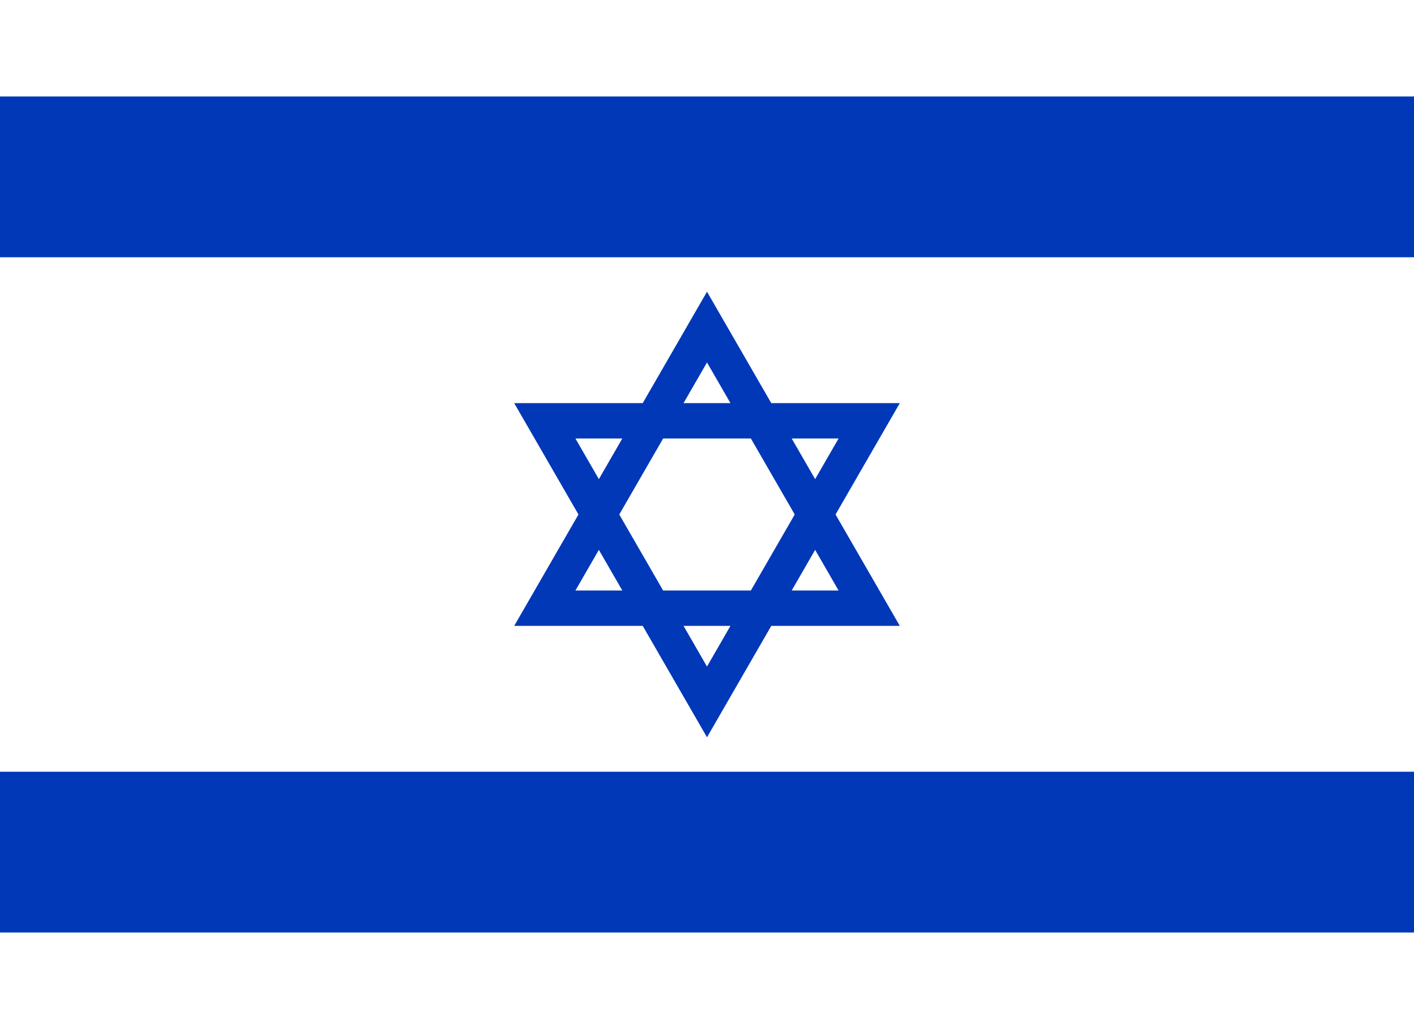
Country: Israel
Committee: ECOSOC (Economic and Social Council)
Agenda Item: Improvising and Strengthening of the Coordination of Emergency Humanitarian Assistance of the United Nations

Israel (officially the State of Israel) was declared in 1948 after Britain withdrew from its mandate. It is a country in Western Asia that shares borders with Lebanon to the north, Jordan to the east, and Syria to the northeast. It is situated on the southeastern shore of the Mediterranean Sea and the northern shore of the Red Sea. Jerusalem is the capital and largest city in the country but Israel’s economic and technological center is a small city called Tel Aviv. Its total land is 21,937 sq km. Israel’s population is 8,914,885 and 74% of their population is Jewish and 21.1% of the population is Arab. The official language of Israel is Hebrew. It has some natural resources such as timber, natural gas, phosphate rock, magnesium bromide, copper, clays, and sand. It is governed by Parliamentary Democracy.

Every crisis and emergency around the world affects humanitarianism deeply in many respects. Yet some of them are more difficult to handle than the others. During the pandemic and Covid-19, humanity not only suffered from certain health issues but also from economical issues. Many Israelis became unemployed or were put on unpaid leave, and the concept of unemployment was modified to fit the new circumstances. After the decline of the lockdowns, the rate of unemployment insurance recipients rose again with the second lockdown and reached 240,000 additional recipients. The crisis led to a major drop in tax revenues and a dramatic increase in government expenditures, increasing the deficit. The government had to increase the national debt in order to cope with the crisis. Israel’s economy was deeply affected during the Covid-19 crisis. Moreover, the people who became unemployed during the pandemic have been affected profoundly in terms of their psychological state.

As Israel, we think the only way to get over Covid-19’s economical damages is to increase production in all areas. If every country started to use its natural sources correctly and efficiently, it could be a great opportunity to get out of the undesirable economic situations which came to light with Covid-19. The pandemic conditions led Israel to use its agriculture and tourism facilities to keep up with the New World. Along the same line, countries have to use their own sources and opportunities to get over this global crisis.

