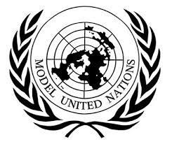
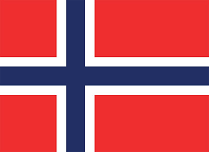
Position: Delegate
School: Mev Colloge High School
Country: Kingdom of Norway
Committee: ECOSOC/2

As Kingdom of Norway we are so proud ,to be in this occasion. The Kingdom of Norway is located in the northernmost part of Scandinavia, cold all year. We are interested in Cultural and Economic Reform and Optimization of the Post-Pandemic United Nations System. The economy of Norway is a highly developed mixed economy with state-ownership in strategic areas. Although sensitive to global business cycles, the economy of Norway has shown robust growth since the start of the industrial era. The country has a very high standard of living compared with other European countries, and a strongly integrated welfare system. Norway's modern manufacturing and welfare system rely on a financial reserve produced by exploitation of natural resources, particularly North Sea oil.

The Kingdom of Norway believes, economic resources should be used in the long term for the development of the people and the country, not for the interests of politicians. In this way, crises can be overcome in the least and reliable way.Before the Pre-industrial revolution, Our economy was largely based on agriculture, timber, and fishing. In May 1963, we asserted sovereign rights over natural resources in its sector of the North Sea. Exploration started on 19 July 1966, when Ocean Traveler drilled its first well.[ Oil was first encountered at the Balder oil field at flank of the Utsira High, about 190 km west of Stavanger, in 1967. Initial exploration was fruitless, until Ocean Viking found oil on 21 August 1969. By the end of 1969, it was clear that there were large oil and gas reserves in the North Sea. However, since the income of a resource that will run out like oil will eventually run out, we invest the money we earn in education and renewable energy resources. During the pandemic, we went through difficult situations like other United Nations countries, but we continue to manage as much as we can. The pandemic recovery offers an opportunity to reinvigorate business dynamism and ensure that education delivers on skills. This will help maintain good living standards and support comprehensive public services.. Due to the low and sparse population and the high level of welfare together with rapid vaccination, the pandemic was overcome without risk and ease compared to many European countries. A broad recovery strategy to attain more sustainable and resilient growth, while retaining good outcomes in equity, would be helped by ensuring taxation remains efficient by keeping the tax burden as low as possible (Panel B), while remaining firmly within the “Nordic” model of comprehensive public services and transfers. In addition, ensuring infrastructure projects are well selected and implemented is important. We have invested heavily, particularly in transport infrastructure, and more so in recent years. However, too many infrastructure projects fall short of best practice in terms of project selection and cost-effective implementation.

Our economy is booming. COVID-19 restrictions are lifted and we are heading out of the pandemic. Economic growth is strong, unemployment is low. A shortage of labor is leading to mounting pressure. Our economy continues rapidly and sustainably after the pandemic, although the disease seems to have been overcome in the short term, it may relapse in the future. We are still trying to turn crises into opportunities by using the money we earn from oil to renewable resources such as water, solar energy, for development.

