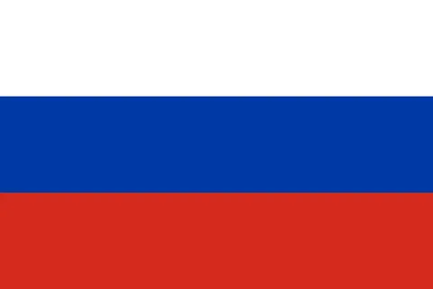
United Nations International Childrens Emergency Fund
Practicing Freedom of Religion With a Special Emphasis on Forcible İmposition of Religion on Young Children
Russia is a country that provides freedom of religion. In Russia, orthodox Christianity is the most widely professed faith with over 60 million people but religion in Russia is diverse with a minority of non-religious people and adherents of other faiths like Islam, Buddhism, and Judaism along with other religions and creeds which constitute an inseparable part of the historical heritage of Russia's peoples. Orthodox Christianity is a really strict religion. For example, Orthodox Christian fasting, which incorporates voluntary abstention from specific foods for 180-200 days per year, is an ancient ecclesiastical ordinance. The Holy Tradition of the Eastern Orthodox Christian Church, while advising avoidance of olive oil, meat, fish, milk, and dairy products every Wednesday and Friday throughout the year, additionally includes four principal fasting periods per year when meat as well as dairy products and eggs are forbidden. Not just in food wise orthodox religion has strict rules about weddings too. Lombardo(a) must be an Orthodox Christian in good standing and be involved in the life of the church. Non-Orthodox cannot assume this responsibility. If the bride or groom were born in Greece and have come to the United States after their 16th birthday, they must have a certificate from their Metropolis in Greece assuring that they have not been married before this marriage. If an Orthodox Christian is asked to participate in a non-Orthodox wedding he/she may not receive Holy Communion at that service. These are some of the guidelines and rules that pertain to people's lives as Orthodox Christians. To Russia, child rights are crucial too. We think that children are important members of society considering when a child grows up and becomes an active member of the society their childhood affects their role as an active citizen. As Nelson Mandela said "The true character of a society is revealed in how it treats its children" In our opinion, child abuse is a serious affair too. Experiencing discriminatory, sexual, physical or, emotional abuse as a child can lead to trauma, mental issues, and anxiety, According to Russia's state law, sexual crimes committed against children will be punished by at least 20 years of imprisonment; under aggravating circumstances, the punishment can be life imprisonment. The only condition on which a sentenced person may become eligible for parole and conditional early release is at his voluntary request for and agreement to undergo medical castration. We think that religion is a common reason for child abuse . In Russia children often grow up leaning into their family’s religion because of the pressure that the family puts their kids into, which is unnecessary. Studies have observed that children who grow up under the imposition of a religion often choose ideologies such as atheism or deism.The healthiest thing to do is to give children time to grow up until they can comprehend what religion they want to be in and let them decide as we persuade . About this topic, we think that leaving the religion part of the chidrens identity blank until they turn 18 would be healthier for their religious freedom To help prevent orphanhood and child neglect and abuse, and to assist families in difficulty, a network of social work and care service organizations was established throughout Russia. The role of non-governmental, non-profit organizations (NGOs) in providing services to vulnerable families and children has increased significantly in recent years. What Russia Should aim to decrease the number of children identified each year as left without parental care and placed in residential care; introduce a no-institutionalization policy for children below school age, irrespective of their health status; and introduce a policy of suitable placement for adolescents. And of course bringing awarenes to the topic is really affective to solving this problem.

