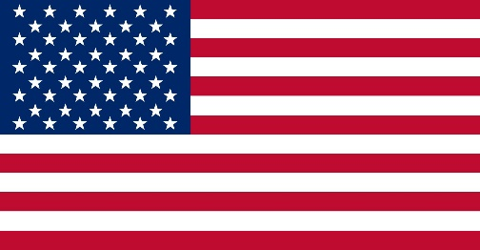
Delegate: United States of America
Committee: SPECPOL
Agenda Item: The Somalia Conflict: Implications for peacemaking and peacekeeping efforts

The United States of America (U.S.A. or USA) is primarily located in North America. It consists of 50 states. The United States is the world's third-largest country by both land and total area. It shares land borders with Canada to its north, Mexico to its south, and maritime borders with the Bahamas, Cuba, Russia, and other nations. With a population of over 333 million, it is the most populous country in the Americas and the third most populous in the world. The national capital of the United States is Washington, D.C., and its most populous city and principal centre is New York City. The United States is the world’s greatest economic power, measured in terms of gross domestic product (GDP). The nation’s wealth is partly a reflection of its rich natural resources and its enormous agricultural output, but it owes more to the country’s highly developed industry. The United States contains a highly diverse population. The United States has a diversity that to a great degree has come from an immense and sustained global immigration. Probably no other country has a wider range of racial, ethnic, and cultural types than the United States.

Unlike many African populations, the overwhelming majority of the Somalis are part of a single, homogeneous ethnic group. All Somalis are Muslim and share the same language and culture. Nevertheless, one of the most terrible civil wars in Africa has been waged in this country for more than two decades. Somalia has been without a functioning central government since the late dictator General Mohamed Siad Barre was ousted in 1991. The fall of Said Barre’s regime and the Somali Civil War created a power vacuum in which nationalist and Islamic groups, warlords, clan and sub-clan militias and other actors aimed to carve out swathes of territory for their own governance. Subsequently, regional and international institutions initiated various peace and reconciliation processes in an attempt to create a stable and robust federal government, with various degrees of success. The inter-clan rivalries have fuelled the tension between the Federal government and the regional states, making the consensus and state-building, as well as peacebuilding, process strenuous. Over the nearly 30 years of conflict, the war has claimed upwards of 500,000 lives, according to estimates from the Associated Press and Africa News in 2007. Since then, the Armed Conflict Location and Event Dataset reports falling numbers of fatalities in Somalia, although more than 3,000 people continue to die in the conflict each year.

