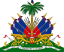
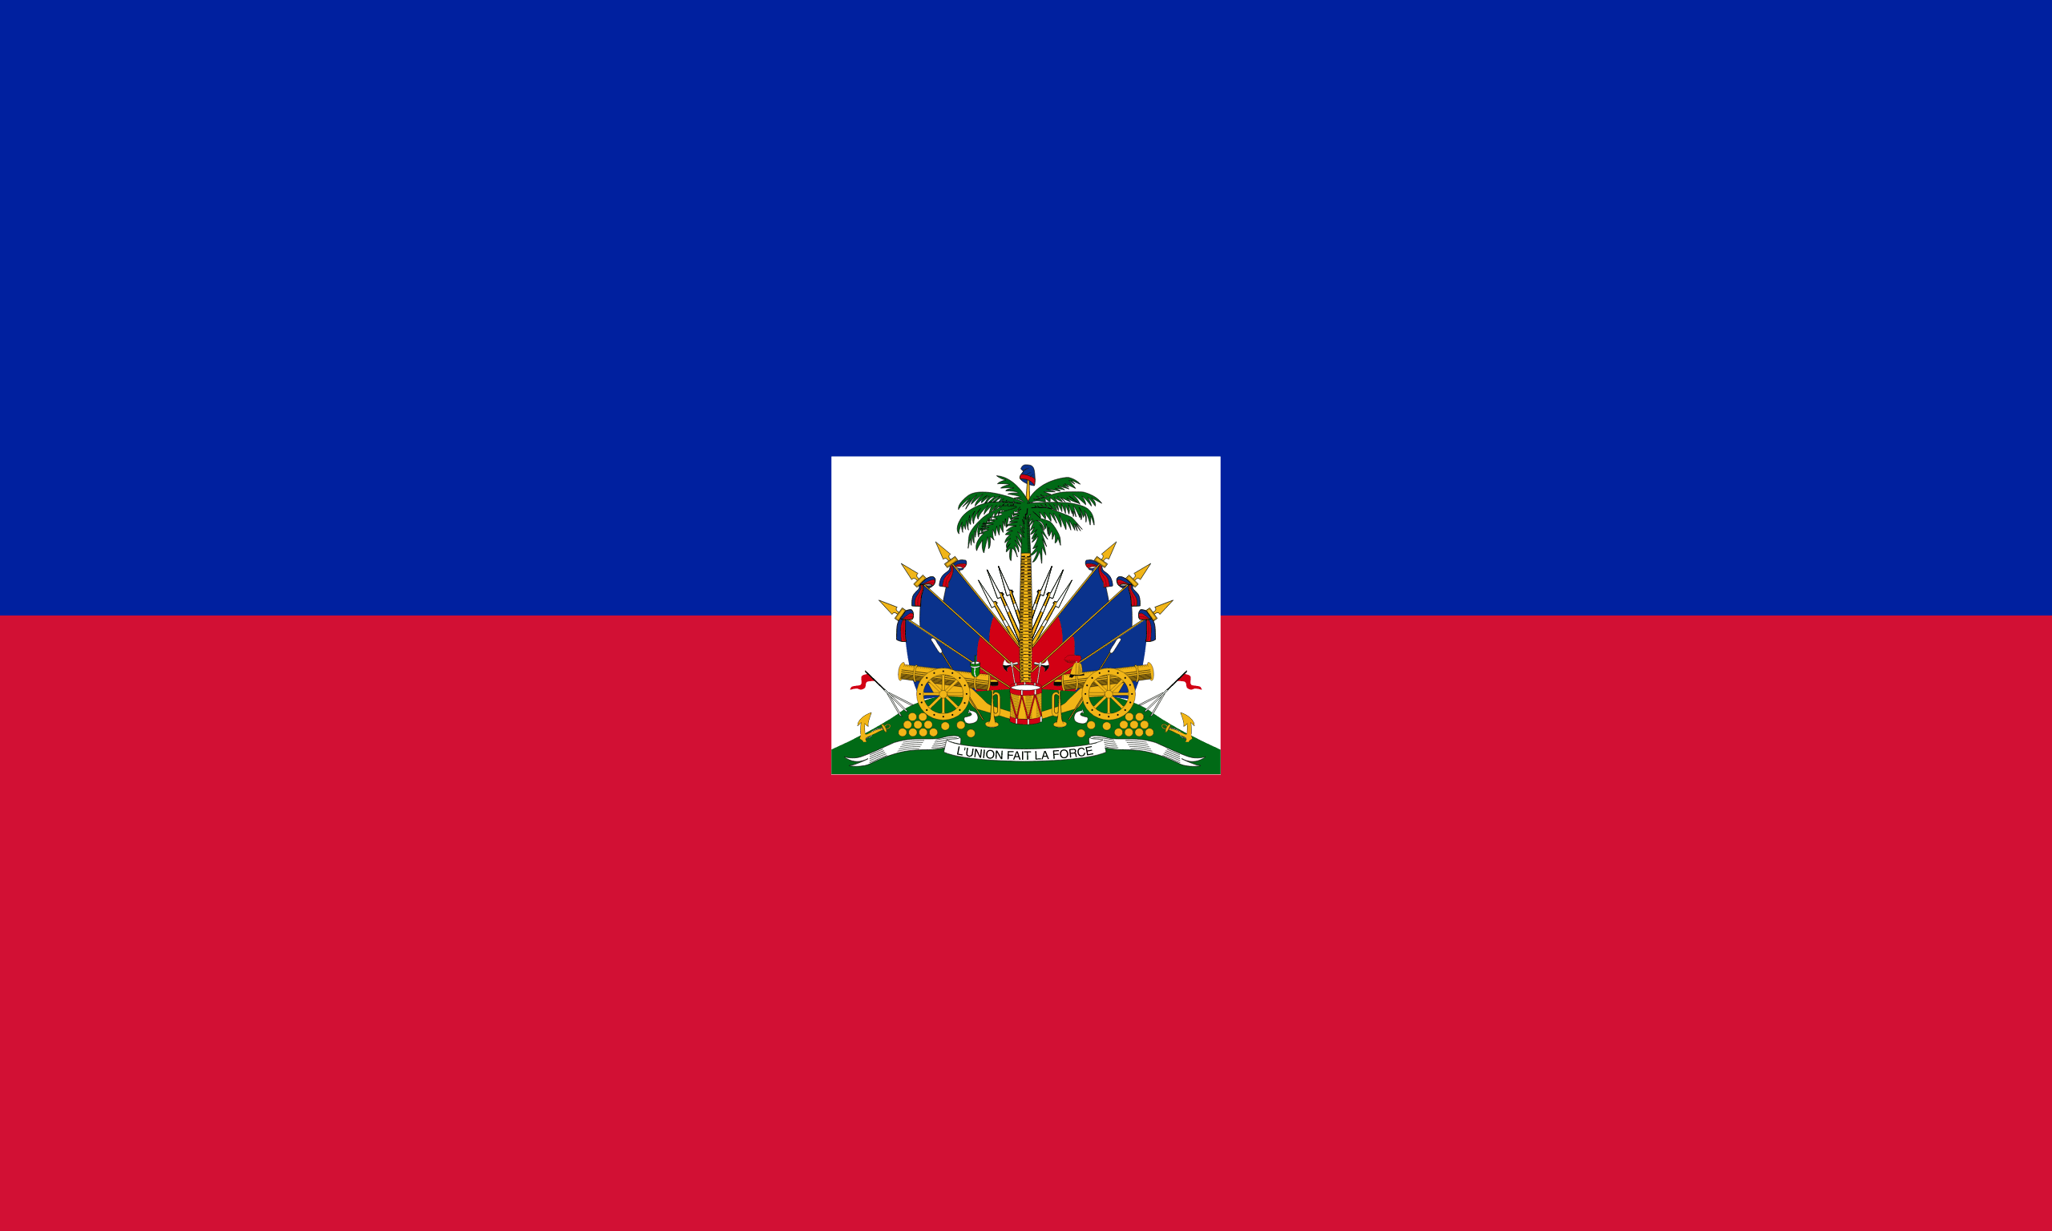
Committee: UNICEF
Country: The Republic of Haiti
Delegate: Sena Güler

The Republic of Haiti is an island country in the Caribbean Sea in America. It shares the island of Hispaniola, located in the east of Cuba, with the Dominican Republic and is in the western part of the island. The country, whose area is 27,750 km², has a population of 11,12 million and its capital city is Port-au-Prince.
Cause
The Republic of Haiti still has acute humanitarian needs. Many communities in the Southwest continued to suffer from the impact of Hurricane Matthew in 2016, especially about shelter and agriculture. UNICEF Haiti transitioned to development programming in hurricane-affected areas. The Republic of Haiti is facing multiple crises, including growing socio-political instability and deteriorating economic conditions, rising food insecurity and malnutrition, the Haitian-Dominican migration dynamic, waterborne disease epidemics, and high vulnerability to natural hazards, all of which have been further exacerbated.
Another problem of the Republic of Haiti is child marriage. 15% of the girls and 2% of the boys in the country are married or engaged before they are minors or at the age of 15.
Policy
The republic of Haiti ratified the Convention on the Rights of the Child in 1995, which sets a minimum age of marriage of 18, and the Convention on the Elimination of All Forms of Discrimination Against Women in 1981, which obligates states to ensure free and full consent to the marriage. During its 2016 Universal Periodic Review, Haiti supported recommendations to establish a legal framework to better protect girls from forced marriage, and to establish a minimum age of marriage of 18 for both women and men.
Haiti has committed to eliminating child, early, and forced marriage by 2030 in line with the Sustainable Development Goals. In 2014, Haiti also signed a joint statement at the Human Rights Council calling for a resolution on child marriage. Haiti co-sponsored the 2013 and 2014 UN General Assembly resolutions on the child, early and forced marriage.
Haiti, as a member of the Organization of American States (OAS), is bound to the Inter American System of Human Rights, which recognizes the right of men and women of marriageable age to marry and calls to governments to strengthen the response to address gender-based violence and discrimination, including early, forced and child marriage and unions from a perspective that respected evolving capacities and progressive autonomy.

Solution
The Republic of Haiti believes that providing economic support and incentives to girls and their families, educating and rally parents and community members, and enhancing girls’ access to high-quality education will dramatically reduce child marriage

