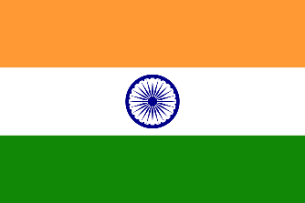
Country: Republic of India
Committee: United Nations Environment Programme
Delegate: Ahmet Kadir Cengiz
Topic: Air and Water Pollution
---------------------------------------------------o-----------------------------------------------------
General Information:
India lies in south Asia, between Pakistan, China, and Nepal. To the north, it is bordered by the world’s highest mountain chain.
The capital of India is New Delhi, and the country's largest cities are Mumbai (formerly Bombay), Delhi, and Kolkata (formerly Calcutta).
India is the seventh-largest country in the world.
India’s population is one billion making it the second-most populous country after China.
India is the largest democracy (Government by the people, like the UK, is) in the world.
India is mainly an agricultural country, though it also has a large iron and steel industry and produces every type of manufactured goods.
India is in Southern Asia, bordering the Arabian Sea and the Bay of Bengal, between Burma and Pakistan.
Cause:
Some have cited economic development as the cause of environmental issues. It is suggested that India's growing population is the primary cause of India's environmental degradation. Systematic studies challenge this theory. Empirical evidence from countries such as Japan, England, and Singapore, each with population density similar to or higher than that of India, yet each enjoying environmental quality vastly superior to India's, suggests population density may not be the only factor affecting India's issues.
Solution:
In 2015, the Government of India, together with IIT Kanpur launched the National Air Quality Index. In 2019, India launched 'The National Clean Air Programme' with a tentative national target of 20%-30% reduction in PM2.5 and PM10 concentrations by 2024, considering 2017 as the base year for comparison. It will be rolled out in 102 cities that are considered to have air quality worse than the National Ambient Air Quality Standards. There are other initiatives such as a 1,600-kilometre-long and 5-kilometer-wide The Great Green Wall of Aravalli green ecological corridor along with Aravalli range from Gujarat to Delhi which will also connect to Shivalik hill range with the planting of 1.35 billion (135 crores) new native trees over 10 years to combat the pollution.[6] In December 2019, IIT Bombay, in partnership with the McKelvey School of Engineering of Washington University in St. Louis, launched the Aerosol and Air Quality Research Facility to study air pollution in India.

