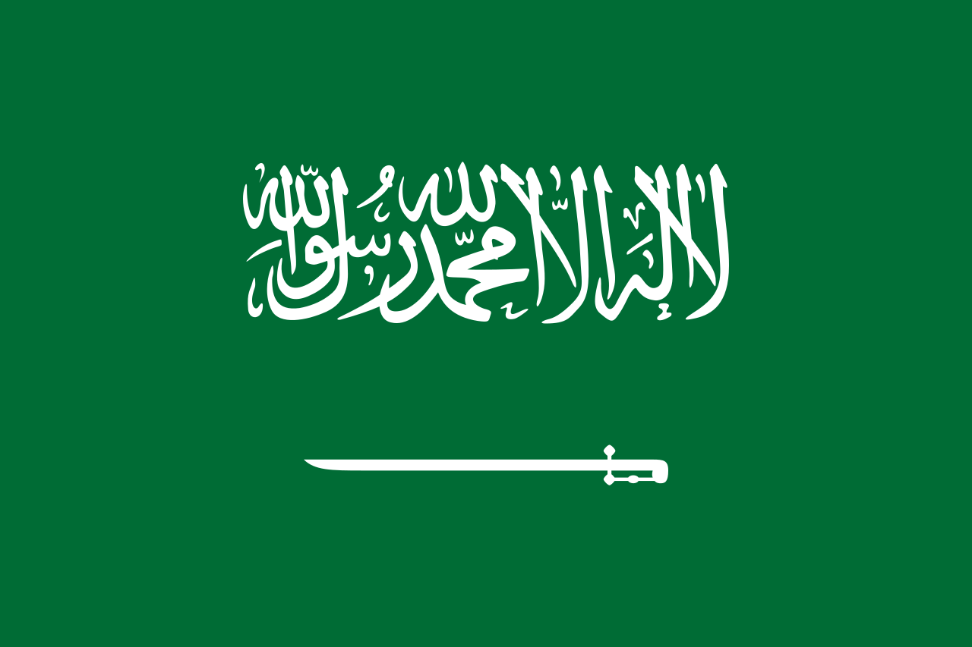
Committee: UNICEF
Country: Saudi Arabia

Postion paper

We as Saudi Arabia we locate at Southwest Asia. We joined UN at 26th of June 1945 and we are an Islamic country since 18th century and ruled by sharia laws as it is called Islamic laws.

In our country religion have an important part in both education and normal life. We have an education both religious and gender discrimination education. As it is with the schools it is compulsory to attend religious primary schools after that it isn’t compulsory to attend school for girl children. No matter what nation,religion and gender if the child is born with a muslim dad the child is muslim.

