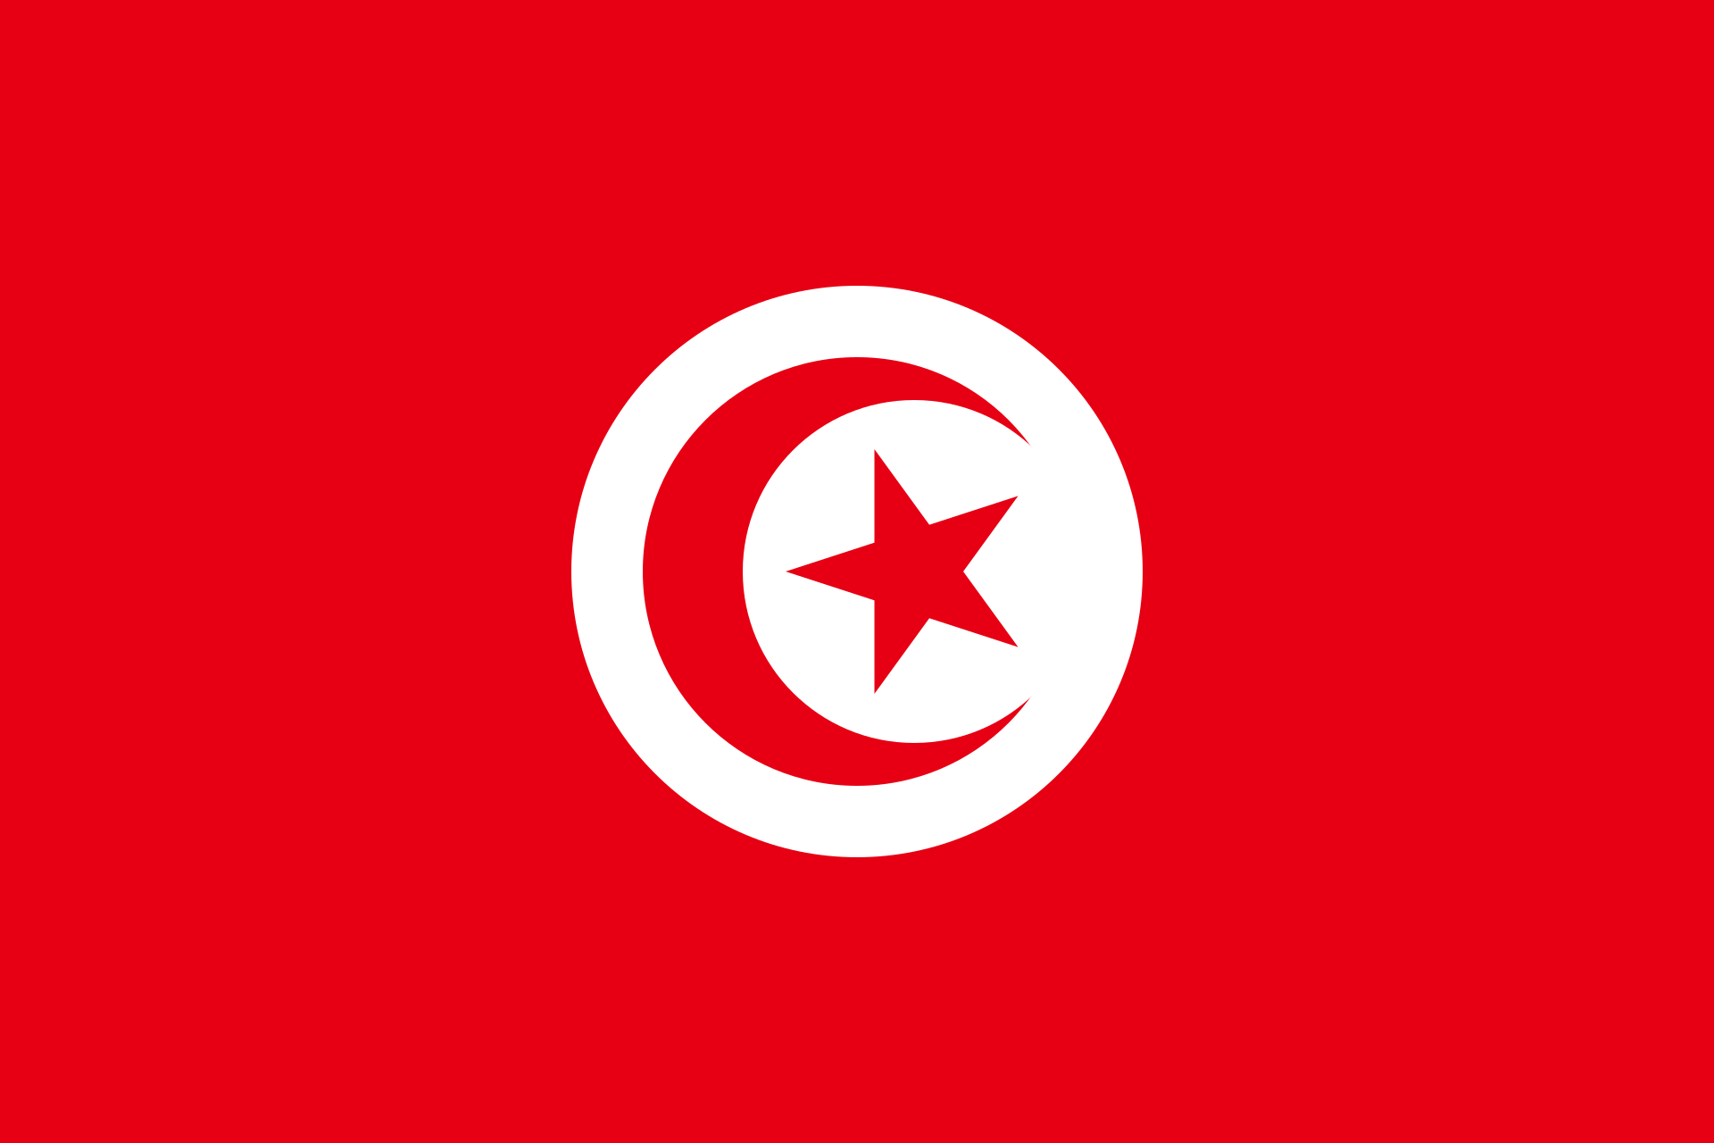
Country: Tunisia
Committee: Commission on the Status of Women
Agenda Item: Promoting gender equality and empwerment of women

Tunisia, or officialy Republic of Tunisia is the northernmost country in the Africa continent. It is a part of the Maghreb region of North Africa, bordered by Algeria to the west and southwest, Libya to the southeast, and the Mediterranean Sea to the north and east. It features the archaeological sites of Carthage dating back to the 9th century BC, as well as the Great Mosque of Kairouan. Known for its ancient architecture, souks and blue coasts, it covers 163,610 km² (63,170 sq mi), and has a population of 12.1 million. It contains the eastern end of the Atlas Mountains and the northern reaches of the Sahara desert; much of its remaining territory is arable land. Its 1,300 km (810 mi) of coastline include the African conjunction of the western and eastern parts of the Mediterranean Basin. Tunisia is home to Africa's northernmost point, Cape Angela; and its capital and largest city is Tunis, which is located on its northeastern coast, and lends the country its name.

Tunisia was the country where the anger that had accumulated for decades flared up after a street vendor named Mohammed Bouazizi set himself on fire and the Arab Uprising started. He ensured the successful overthrow of Zeynel Abidin Ben Ali, who has been the president for 23 years, together with the revolution. This was followed by the remarkable success of the Islamist Ennahda Movement, which had been away from politics for a long time, in the 2011 elections.

Rights such as gender equality, prohibition of polygamy and civil law marriage in Tunisia were guaranteed by the 1956 constitution. This arrangement, which affects all areas including heritage, their place in the family institution, their participation in social life and the economy, has brought a conscious and organized tradition of struggle to Tunisian women over the years.

