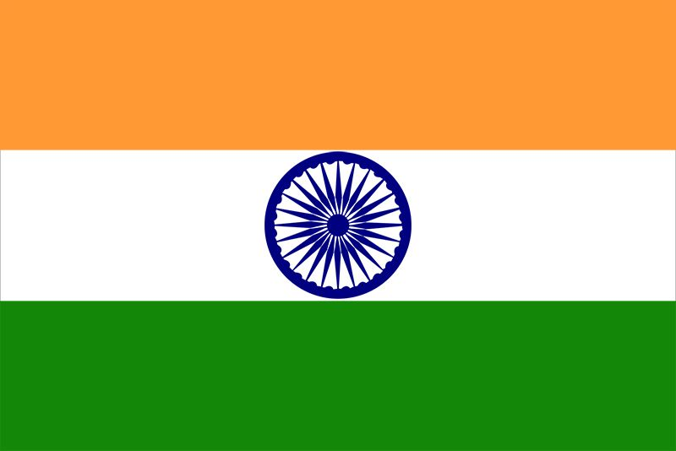
Country:India
Committee:FAO (Food and agriculture organization of United Nations)
Agenda Item:Ensuring sustainable food production and distribution to accommodate the increasing world population
India is in southern Asia bordering the Arabian Sea and the Bay of Beryal between Burma and Pakistan. India borders Bangladesh and Myanmar to the east, Bhutan, China and Nepal to the north, Pakistan to the west, and Sri Lanka to the south. India's climate ranges from tropical monsoon in the south to temperate in the north.India has 1,266,883,598 million people.India’s areas is 3,287,263 sq km.India’s currency is INR.
India is the second most crowded country in the world.Aryan tribes from the northwest infiltrated the Indian subcontinent about 1500 B.C;their marger with the earlier Dravidian inhabitants created the Indian culture.India’s economic reforms in 1991,a massive youthful population and strategic geographic location have contributed to India’s emergence as a regional and global power.However India still faces pressing problems such as widespread environmental degredation.India has been active at the United Nations since its foundation in 1945.It is the twelft largest economy in the world based on a developed economy and well developed international trade networks.India overtakes China to become world’s most populous country.The decrease in the birth rate the increase in the numbers of the old people were effective in the decrease in the population of the country.
.In India geverned by a multi-party parliamentary democracy the parliament has two chambers the provincial Assembly (Rajye Sabha) and the people’s Assembly (Lok Sabha).The people’s Assembly has 543 seats and is elected every five years.Seemingly India with its highly growing population will have difficulty feeding their mation.Edible insects can be long run solution fort he biggest population of the globe.Along with good farming practices,high techusage which is powerful side of India can be used to harvest more product per acre.Finally more budget should be allocated to irrigation,high quality and incentives for all inputs.

