Country: Sudan
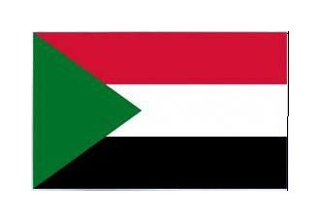
Committee: food agriculture oganization

Sudan, People’s Republic of Sudan ,Sudan is an East African country . It has a total of 7 neighbors in the North of Egypt ,Libya northwest ,Chad west ,Cetral Africa southwest ,South Sudan South ,Ethiopia southeast ,Eritrea east ,Red Sea northeast . Its Sudan capital city is Harmut. With a surface area of 1,886,068 km2 ,it is the 16th largest country .Sudan rank 33rd with a population of 43,426,060 .
In recent years Sudan’s agricultural activities have been decreasing gradually . But third World countries are not aware of this. Cotton producton in Sudan is declining for example ,432 bales were sold in 1990 ,while cotton production is still in decline .Sudan lost 2 million people because of food shortage “Why does no one see why Sudan is in troble?”
Sudan has these and many more problems. There is no equal distribution of food in Sudan %70 of Sudan is below the hunger threshold. Sudanese people are experiencing difficulties. Even if there is agricultural land there is no one to work with. In theese difficult days of Sudan, we ask the African Union and European countries to take a look at Sudan.

