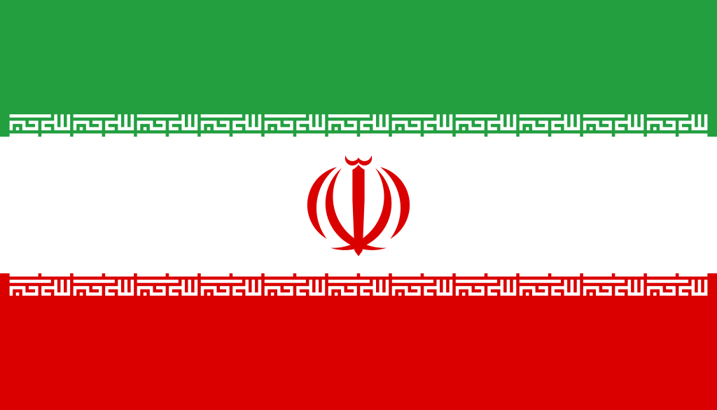
Country: Iran
Comittee: World Health Organization (WHO)
Agenda Item: Uncontrolled use of technology and digital obesity
Iran by the past name Persia in the original Islamic Republic Of Iran, country of Western Asia.Iran is the 17th largest country in the World and the second largest in the Middle East.The country maintains a rich and distinctive cultural and social continuity dating back to the Medes period, which began in 550 bce. In recent decades it has become known for its unique regim of Islamic republic.It meets 14% of the worlds petrol oil needs and it’s countrys main source of income.
First of all, technology addiction. Iran ranks 73rd out off 143 countries in the ranking of technology developed countries.It is not a developed country in terms of technology and many social media platform is banned.So in Iran technology addiction is low it’s %20 in 2016-2017.Technology addiction has a lot of harmful effects.Spiritually can have a severe impact on one's mental health, exacerbating or contributing to anxiety, depression, attention deficit hyperactivity disorder as well as other disorders. Technology addiction also can lead to restlessness, irritability and anger.In human health causes eye disorder,hunchback,joint pain.Socially lead to poor relationships with friends and family.Teens look at the phone an average of 7 hours a day and 12% of teen boys are addicted on video games.
To break technology addiction:Schedule times to check your phone your

