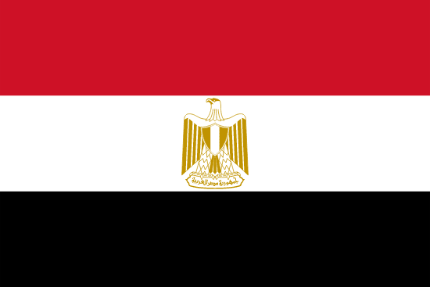

Country : Egypt
Committee : Food and Agriculture Organization of the United Nations (FAO)
Agenda Item : Research on agriculture and food in Egypt and solutions to problems.

Egypt is located between Libya, Gaza Strip and Sudan, bordering the Mediterranean Sea in Africa while including the Sinai peninsula in Asia. Egypt has a very rich historical background along with its geography. In ancient times, it has hosted some of the world's oldest civilizations on its territory, with their religious diversity and pyramids which is thought to have been built as early as B.C 2500 . Egypt, which remained in the borders of the Ottoman Empire for 396 years, was separated from it in 1914. According to 2022 data, with a population of 104 million, it is the world's 14th and Africa’s 3rd most populous country.

Egypt, whose capital is Cairo, is a member of the Food and Agriculture Organization (FAO) of the United Nations as well as a member of many international organizations. It was established in Canada in 1945 in order to prevent hunger and nutritional deficiency, fight poverty, protect natural resources, raise the economic status of agriculture, forestry, fishing activities. The Egyptians are considered to be one of the first groups of people to farm on a large scale. They were able to take advantage of the small floods in the Nile River in a controlled manner and thus agriculture showed great development. They also produced the world's longest fiber cotton, as they benefited from plants in mummification processes. They are also very rich in fishing opportunities. Food and agricultural activities provided the biggest export income after petroleum products in world trade. However, the political instability that emerged with the military coup that took place in 2013 has also deeply affected agriculture. In the years after the military coup, many states imposed economic and political embargoes on Egypt. In this case, it caused crisis and poverty.

According to the Food and Agriculture Organization of the United Nations (FAO) report published last month, climate changes, drought all over the world led to difficulty in accessing basic foods. Also Covid-19 epidemic increased the hygiene problem in basic food. Not only for Egypt but for the entire Arab region hunger and malnutrition reached critical levels. Food and Agriculture Organization of the United Nations (FAO) should cooperate with the Egyptian government and encourage the State of Egypt to make legal arrangements that will legally guarantee the fundamental rights of its citizens. Investment programs to support agriculture and production should be established. All international organizations should support the Egyptian people.

