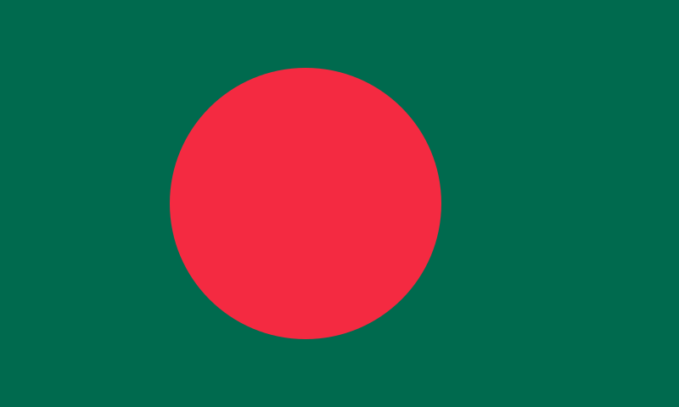
Country: Bangladesh
Committee:Commission on the Status of Women
Agenda Item:Promoting gender equality and empowerment of women
Bangladesh, People's Republic of Bangladesh, Gana Prajatantri Bangladesh, country of southern Asia. Bangladesh, which is the 8th most populated country in the world, has an important place in terms of population. Bangladesh was a country affiliated to Pakistan until 1971, but started the War of Independence as a result of language problem, lack of political representation, economic discrimination and military pressure. Agriculture plays an important role in the economy and about 47% of the population works in the agricultural sector. Bangladesh also has an important place in the export of seafood around the world.
During the War of Independence, Bangladesh women raised awareness about gender equality by participating in the war and taking on important roles in society. The 1972 constitution gave women the right to vote and be elected. The first female MPs were elected in 1973. The "National Commission for the Rights and Development of Women Law" enacted in Bangladesh in 1974 supports the equal representation of women in social, economic and political life and the elimination of discrimination based on gender. Bangladesh adopted the Declaration of the Rights of Women in 1995. This declaration emphasizes the need to respect and protect the human rights of women. In 2010, the Laws on the Prevention of Violence Against Women and Children ensure that crimes of violence against women no longer go unpunished and that victims of violence are also provided with free legal aid, medical treatment and psychological counseling. The Family Courts Law, adopted in 2017, is seen as an important tool especially for the protection of women's rights and the prevention of domestic violence.In Bangladesh penal code 2020, the crime of rape is now punishable by life imprisonment or the death penalty. Sexual assault is punishable by at least 10 years in prison. Child abuse offenses are also heavily penalized, and the law also highlights the difficulties women face, especially in marriage, and criminalizes domestic violence.
More appropriate legal arrangements should be made to protect women's rights.There should be institutions that can help women in situations such as rape and abuse. Women should have economic independence so they can better defend their rights. Education and awareness is one of the important things, women know their rights and they become more sensitive to women's rights in other people. On women's rights, if men are included, they will show more respect for the rights of the women and more support will be done. We must support women's rights and not let any woman die because of inequality.

