

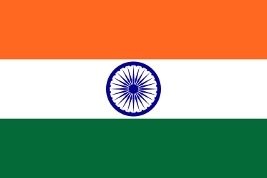

***Country:Indıa***

***Commitie:Disarmament and International Security Commitie***

***Delegate:Efe Barlas***

India is firmly dedicated to the global pursuit of disarmament and non-proliferation, particularly in the context of chemical and biological weapons. As a responsible member of the international community, India ratified the Biological Weapons Convention in 1974 and the Chemical Weapons Convention in 1996. These commitments underscore our dedication to eliminating the threat posed by these weapons. By adhering to these conventions, India actively participates in efforts to prevent the development, stockpiling, and use of biological and chemical weapons, contributing to the establishment of a safer world for all

India places a strong emphasis on transparency in its approach to chemical and biological weapons. The country actively engages in confidence-building measures and information exchanges as outlined in the BWC. In line with the Chemical Weapons Convention, India declared and subsequently destroyed its chemical weapon stockpiles, demonstrating a proactive stance toward disarmament. By complying with reporting requirements and collaborating with international organizations, such as the Organization for the Prohibition of Chemical Weapons, India works to strengthen global efforts against the proliferation of these hazardous weapons

India acknowledges the global nature of the challenges posed by chemical and biological weapons. The nation actively collaborates with other countries and international organizations to enhance preparedness and response mechanisms. India's focus is on preventing the acquisition of these weapons by non-state actors, and the country shares its expertise to contribute to the collective security of the international community. By fostering cooperation on a global scale, India aims to create a world where the menace of chemical and biological weapons is effectively addressed, fostering a safer and more secure future for all.