Committee: United Nations Children's Fund (UNICEF)

Agenda: Assessing the Current Situation of Child Labor

State: Kingdom of the Netherlands

Delegate: Zeynep KARAARSLAN

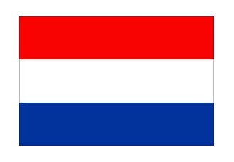

Child labor is a grave concern that affects millions of children worldwide. The Netherlands, as a country committed to upholding human rights and social justice, takes a strong stance against child labor. The Dutch government firmly believes that every child deserves a safe and nurturing environment, free from exploitation and labor.

The Netherlands has strong laws that say children should not work in dangerous or harmful jobs. These laws make sure that children can grow up in a safe and healthy environment. Companies in the Netherlands must follow these laws and make sure they don't use child labor in their businesses.

Education plays a vital role in breaking the cycle of poverty and reducing child labor. The Netherlands places great emphasis on providing quality education for all children. The government invests in schools, implements awareness campaigns, and promotes inclusive education policies. By ensuring access to education, the Netherlands aims to empower children and equip them with the necessary skills for a brighter future. Education helps children learn and develop their skills, so they can have a better future. By providing free education, the Netherlands helps children stay away from child labor.

Also they organize campaigns and activities to raise awareness in schools, communities, and organizations. By teaching people about child labor, they hope to prevent it and protect children's rights. By working with international organizations, they can join forces with other countries to stop child labor all around the world.

They teach people that child labor is wrong and harmful. They use pictures, stories, and videos to show how it can hurt children. They tell everyone that children should go to school, play, and be happy, not work in dangerous jobs. They want everyone to know that child labor is not allowed and that we should protect children and give them a chance to grow up safe and healthy.

Last things last, The Netherlands helps children who have been hurt or feel sad to feel better and be part of society again. This helps children who have been hurt to feel better and be happy again.

In conclusion, we as a delegation of the Netherlands firmly believe that every child deserves a childhood free from exploitation and labor. We want every child to be happy, safe, and free.