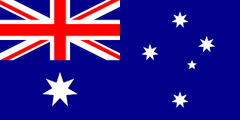
Country: Australia
Committiee: SOCHUM
Agenda Items: Taking action in response to the global emergance of counter culture, new-left and anti war movement.

Australia is located between the Pacific and Indian oceans in the Southern Hemisphere, the smallest continent an done of the largest countries on earth.
This geopolitical position may seem like a beneficial thing, but it has always caused Australia to remain neutral in its political relations. Staying neutral is always a good thing, after all, maybe what Australia is doing is the good thing. In the 1960s, a counterculture movement was seen mostly among the young population, young people opposed traditionalism and resorted to changes in their culture.

The term "counterculture" refers to the experience an individual or group of people have when encountering another culture that is different from their own. We can give examples of this, such as the changes in music, fashion and social life. At that time, especially due to the Vietnam War, young people's interest in anti-war movements increased. These anti-war movements showed that people supported peace, but there were various reactions in society against the movements, which showed that the mentality of the society was different.

