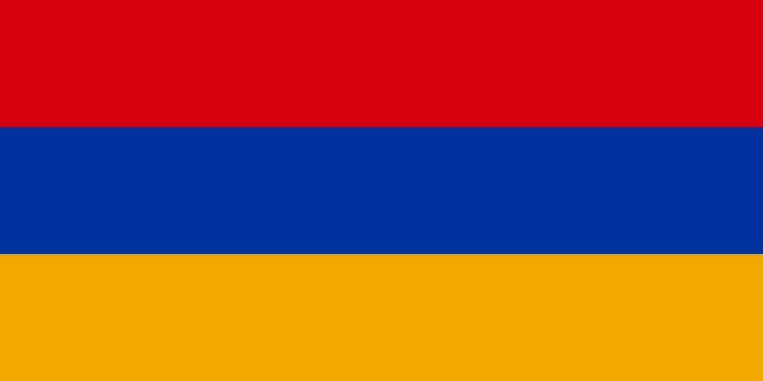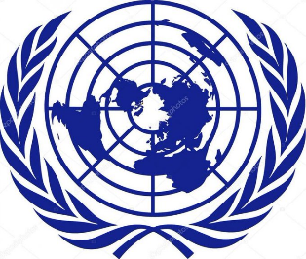

Committee = Special Political and Decolonization Committee
State = The Republic of Armenia
Agenda = The Somalia Conflict; Implications for peace-making and peacekeeping efforts.
School = Private Denge Anatolia High School
Delegate name = Hazal Oğuz

The Republic of Armenia is a landlocked country in the Armenian Highlands of Western Asia. It is a part of the Caucasus region and is bordered by Turkey to the west, Georgia to the north, the Lachin corridor (under a Russian peacekeeping force) and Azerbaijan to the east, and Iran and the Azerbaijani exclave of Nakhchivan to the south. Yerevan is the capital, largest city and financial center.
Since the 1988, there is a domestic civil war occurring in Somalia. Somalia had no central government since the start of the civil war, it is considered to be one of the most dangerous countries in the world. The country suffers from food and water deprivation, depopulation, terrorism, migration, corruption, numerous human right violations, instability.
The republic of Armenia has been always promoted peace and human rights. It is a member of many social organizations such as UN, Council of Europe, the Asian Development Bank, the European Bank for Reconstruction and Development, the European Political Community, the Commonwealth of Independent States, the Organization for Security and Cooperation in Europe, the International Monetary Fund, the World Trade Organization, the World Customs Organization, the Organization of the Black Sea Economic Cooperation and La Francophonie. Armenia is willing to fulfil its part to make a better Somalia.

