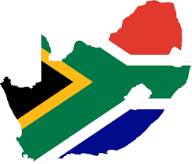

Country: South Africa
Committee: Food and Agriculture Organization
Agenda Item: Ensuring sustainable food production to accommodate the increasing world population

South Africa is the 24th biggest country in the world. The coordinates of South Africa are 22°10'-34°55 South, 16°30'-32°55 east. It has an open economy across South Africa and its foreign trade volume corresponds to about half of GDP. In the last 10 years, trade with other African countries has also developed considerably. South Africa is a developing country and democratically governed.
South Africa is an agricultural country. That’s why %75,3 of South Africa is using for agriculture. But even though in South Africa one out of 5 people namely 450 thousand of people to face hunger. It is equal %20,2 of people of South Africa.
South Africa had many policies but most of them were failed. But South Africa tries to develop new policies to vanish the hunger and make arable land more productive.
We as South Africa is designing new solutions to vanish hunger and make arable land more productive. Such as renewing water systems in agricultural lands, provide financial support to the producer and raising a conscious generation.

