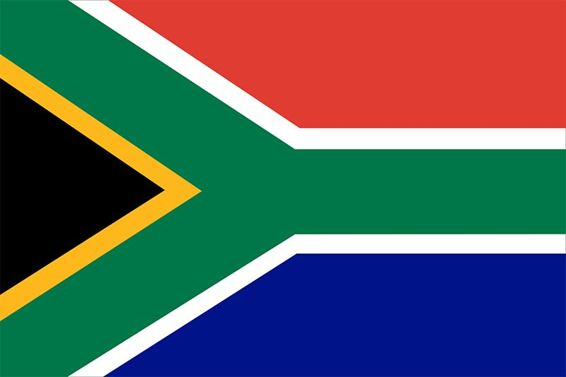
Country: South Africa
Committee: CSW

The Union of South Africa, which changed it’s name to South Africa in 1961, is located at the southern tip of the African continent. South Africa is bordered by Namibia, Botswana, Zimbabwe and Eswatini. It also completely surrounds Lesotho. It has coastlines on the Atlantic Ocean and the Indian Ocean. South Africa became a part of UN in 1945, but was expelled in 1974 because of the apartheid regime that advocated racism, then readmitted in 1994 with the help of the peaceful policies of Nelson Mandela. South Africa has three capitals Cape Town, Pretoria and Bloemfontein. Cape Town is for legislative, Pretoria executive and Bloemfontein is for judical affairs. The current population of South Africa is about 61 million and. It’s the 24th largest country with 1,219,912 km2. Nelson Mandela played a big role in the liberation of Africa.

South Africa’s rank in gender equality is 20th out of 146 countries. It isn’t bad but there is a problem. Women and girls are responsible for housework and they are less likely to be employed. Even if they are hired they get paid less then men. Women’s Access to education services is more limited than men. In 2018, women between the ages of 15 to 49 reported being subjected to physical violence. In addition, the murder of more than 30 women by their husbands in a month created chaos. Womens accused the government of failing to prevent these crimes. There are many problems about gender inequality in the World. Because of poverty, colonial culture from the past and underdevelopment in South Africa, unfortunately African women should be stronger than other women. Despite these bad events, effort are being made to empower women. In South Africa, the presidency of the constitutional court, the defense ministries and the economic adviser to the president are run by women. Also the agricultural sector in Africa is largely in the hands of women.

As the Republic of South Africa, our government will spend a large part of the country’s budget on the education of girls. By cooperating with other countries, we will ensure that women are educated and empowered in areas such as economy, politics and health. Also we will make sure that women in the country have the same opportunities as men. By educating the boys, we will change the way they look at women and teach them that women are equal to them and not lower class.

