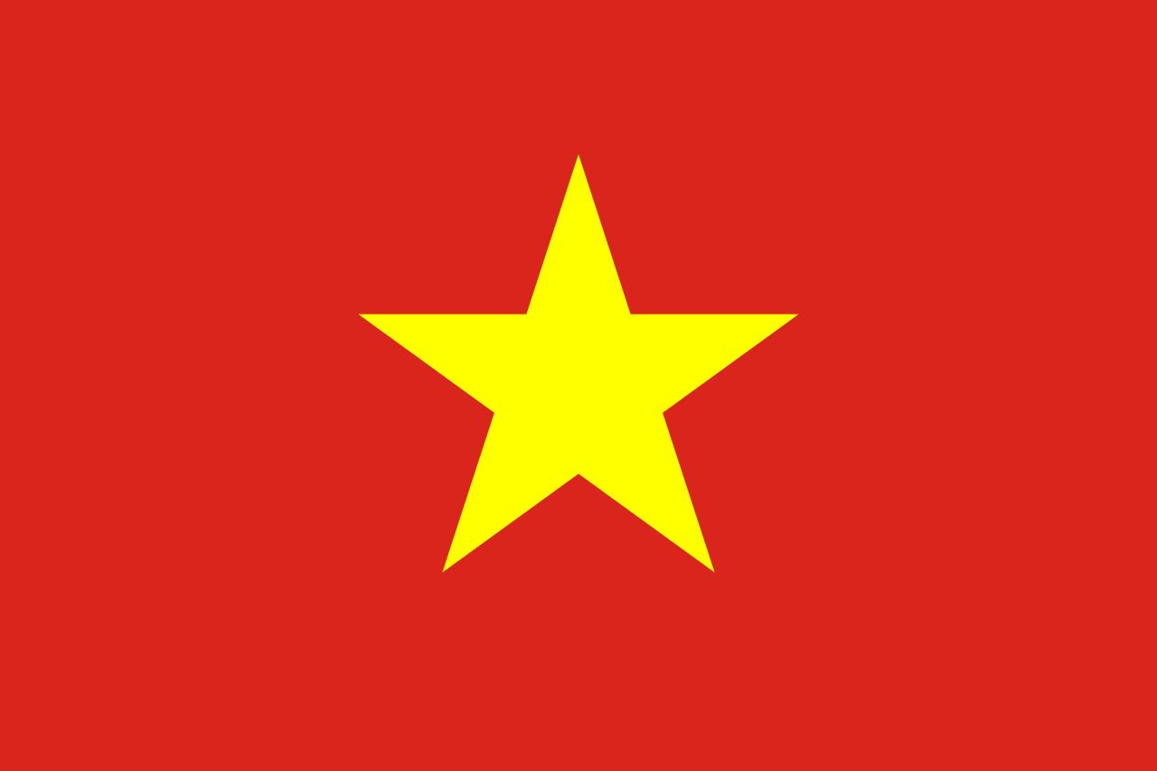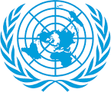
Legalization of Euthanasia
Country: Vietnam Socialist Republic
Committee: World Health Organization (WHO)
Delegate: Özgü Türkkan

First of all, the socialist Republic of Vietnam, as a country that has declared its independence, is a country that can carry out permanent initiatives with an international aspect, such as the world health organization.
The World Health Organization has adopted improving universal health coverage as its founding purpose, preventing diseases that may or may pose a threat to the World, and providing services to vulnerable people. The World Health Organization, whose foundation dates back to 1948, has provided numerous services in the field of health. Connecting partners and people, this organization aims to achieve the highest level of health everywhere. The World Health Organization, which includes a total of 90 countries, has greatly increased its work today. One of the countries supported by the World Health Organization is the Socialist Republic of Vietnam.
The Socialist Republic of Vietnam is a country whose history is almost 4000 years old. 1 in B.C. 10 From the century. The Socialist Republic of Vietnam, which lived under Chinese pressure for a century, gained its independence in 939. in 968, the Socialist Republic of Vietnam introduced itself to the world. In this way, it has become an independent country open to development.
Although euthanasia is not an accepted practice worldwide, it is divided into two groups: passive and active. Although active euthanasia is practiced in countries such as Canada, Belgium, Spain, the area that occupies the largest percentage of acceptance is passive euthanasia.
Although the Socialist Republic of Vietnam declared its independence many years ago, the pressure on it has not completely lifted. Although this pressure affects the studies in most fields, it has shown its effect most in the field of health. In the Socialist Republic of Vietnam, euthanasia is not legally practiced. For this reason, we have no clear data. That is, we cannot reach a correct and specific conclusion about euthanasia.
The ethics of euthanasia is still a subject of great debate today. There are some problems in terms of the compliance of euthanasia with the ethical rules and the way it is applied. These problems concern the Socialist Republic of Vietnam as well as other countries.
55% of the Socialist Republic of Vietnam belongs to the religion of Buddhism. At this point, euthanasia also creates problems for us from a religious point of view. These problems are not very relevant because they are based on religion, but I can't go without saying that; although religion occupies a small percentage, it can create internal confusion.

