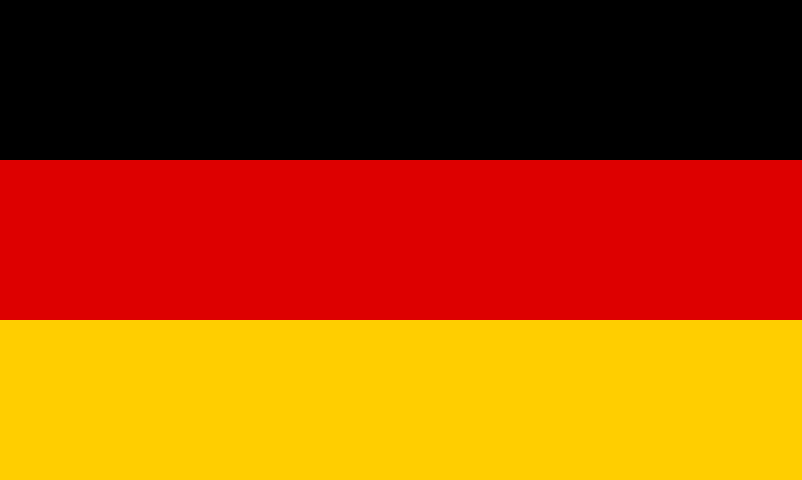
Committee: UNICEF
Country: Germany
Agenda Item: Practicing Freedom of Religion With a Special Emphasis on Forcible Imposition of Religion on Young Children

Germany is a democratic, federal parliamentary republic and the seventh-largest and the second-most populous country in Europe. The country is composed of sixteen states. The states have their own constitution and are largely autonomous in regard to their internal organization. Children constitute 10.8 millions of the population of 83.9 millions, according to the data. Germany is an intercultural and multi-religious country. The majority of Germans are Christian, either Roman Catholic (29.0%), Protestant (27.0%) or Orthodox (1.9%). Muslims make up 4.4% of the population. And 34% of the population belongs to the “others” category. Today, almost one in every ten Germans comes from a foreign country. The largest minority are Turkish. The greatest number of immigrants, as of 2021 in Germany were from Romania, Poland, Bulgaria and Turkey.

In some countries, religion is being imposed on children in social life, school life and at home. Especially, for a certain part, this is a must rather than an option. However, at this point, the right of the person to choose their religion is violated. According to conventions, everyone has the right to freedom of thought, conscience and religion, and also, states parties shall respect the right of the child to freedom of thought. In Germany, the freedom of religion, conscience and freedom to confess one's religious or philosophical beliefs as stated in article 4 of the German constitution are inviolable. It is supported by the statement "No one may be prejudiced or favored because of their gender, descent, race, language, homeland and place of origin, faith or religious or political views." from article 3. According to the Constitution, religion or ethics classes are taught regularly in public schools. These courses are given without violating the state's right of supervision.
To sum up, Germany has all the legal protections for young children and for religious freedom. In order to, prevent Germany from having units forcing children to a religion or belief, and furthermore, to show a way to the United Nations countries for preventing discrimination, or even for crimes caused by religious conflict, our suggestion is to educate young children on religion, however, to not force them into. We believe it is possible, if the countries take action together and take the blinders off for a peaceful world. Governments shall determine discriminaiton by educating all the members of a family about the freedom of a child and by educating the children about different religions.

REFERENCES
https://www.unicef.org/child-rights-convention
https://www.cairn.info/revue-societe-droit-et-religion-2013-1-page-185.htm
https://www.unicef.org/ukraine/media/14436/file/Implementation%20Handbook%20for%20the%20Convention%20on%20the%20Rights%20of%20the%20Child.pdf
https://www.humanium.org/en/children-and-religions/
https://en.wikipedia.org/wiki/Religion_in_Germany
https://www.state.gov/reports/2021-report-on-international-religious-freedom/germany/

