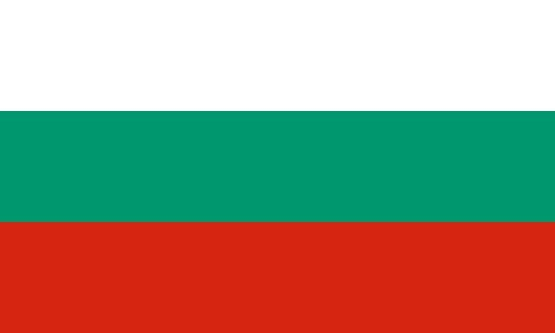
Country: Bulgaria
Committee: North Atlantic Treaty Organization (NATO)
Agenda: Role of NATO in the Middle East and Potential Actions to Be Taken Regarding the Syrian Civil War in NATO's Absence

Southeast European countries make up the Balkan Peninsula, where the Republic of Bulgaria is situated. Bulgaria is one of the oldest nations in Europe, having been founded in the seventh century. In 1908, Bulgaria declared its freedom from Ottoman authority, and by the middle of the 20th century, it was firmly encircled by the Soviet Union. In the 1990s, as the communist regimes started to disintegrate, Bulgaria was freed from Soviet domination. Bulgaria joined the European Union (EU) in 2007, and the North Atlantic Treaty Organization (NATO), firmly establishing its current orientation toward the West. One of the more reliable partners among EU countries is Bulgaria. There are 27 provinces in all, plus a capital province (Sofia-Grad). Its official currency is the Bulgarian Lev. Around 7 million people call Bulgaria home, with 85% of them being Bulgarian. The official language of the nation is Bulgarian, and 60% of the populace practices Bulgarian Orthodoxy.

30 nations from North America and Europe make up the NATO security alliance, which was established in 1949 with the signing of the Washington Treaty. It creates a special connection between these two continents, allowing them to consult, work together on defense and security projects, and coordinate international crisis management activities.
Bulgaria, located in southeast Europe, decided long ago to join NATO. NATO has included the Republic of Bulgaria as a member since 2004. Being a part of East-central Europe, Bulgaria is a crossing point and a transitional zone between West Europe, the Near and the Middle East, and the Mediterranean region.
The Middle East issues have had an impact on every nation in the world, including Bulgaria. Bulgaria, a NATO member that works to resolve crises and conflicts in the Middle East, is willing to take whatever measure to accomplish so

https://en.m.wikipedia.org/wiki/Bulgaria
https://en.m.wikipedia.org/wiki/Geography_of_Bulgaria
https://en.m.wikipedia.org/wiki/Politics_of_Bulgaria

