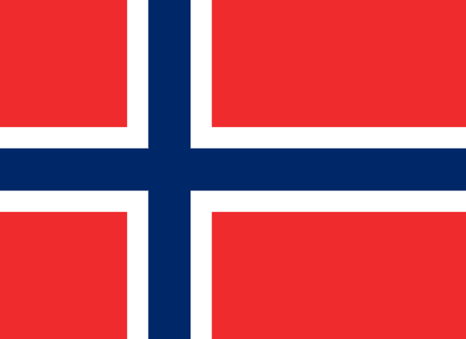Delegation: The Kingdom of Norway
Committee:Disarmament and International Security Committee (DISEC)
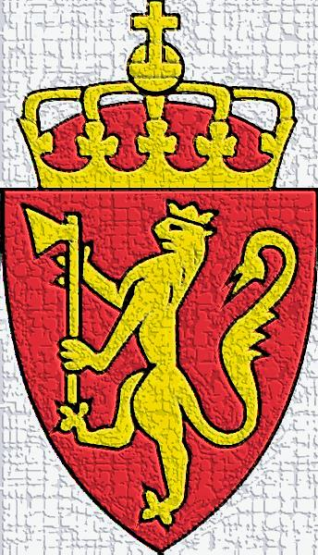
Agenda Item: Israel-Palestine Conflict

About Our Country
Norway, in its full name, is the Kingdom of Norway, which is a country in the west of the Scandinavian Peninsula, located in Northern Europe.. It has borders with Russia, It is the 4th largest country in Europe with an area of 385.207 km2. it is a country and its capital is Oslo, which is its largest city of Norway.The population of Norway is 5,367,580 and the highest populated city in Norway is Oslo. Norway is also a NATO country.On the other hand, Norway is a member of EFTA (European Free Movement Organization) together with Switzerland, Iceland and Liechtenstein..
The Issue and Our Country’s Point of View
The Kingdom of Norway is a country that has always advocated peace and we believe that every country in the UN stands for peace. The Israel Palestine conflict is a humanity issue and has affected our country as well as the whole World. As you know, Norway has always believe that there is nothing that peace cannot solve,and,as usual, it will strive and strive to do what is necessary in the name of peace in this problem.
Both countries declare rights in and around Jerusalem,but,as you know,this is not just declaring rights. The conflict between Israel and Palestine has become a war and has been going on for dec.The point of view of our country,of course,is to achieve common peace and reconcillation of the parties.
Our Sollution Ideas
Norway proposes to achieve recomciliation between them, as in the Oslo accords,and to prevent the formation of problems that will prevent the occurrence of further problems, Norway’s sollution ideas are as follows:
- An agreement must be made between the parties dec(If requested, Norway is proud to mediate again.)
- Troops should be deployed by the UN to oversee the borders of Jerusalem and its environs.
- The parties must promise that they will not break the agreement. and if they do not keep their promises, they should determine something suitable that they will lose when they break the agreement.
- The protection of the articles in the contract must be under the responsibility of the UN.

