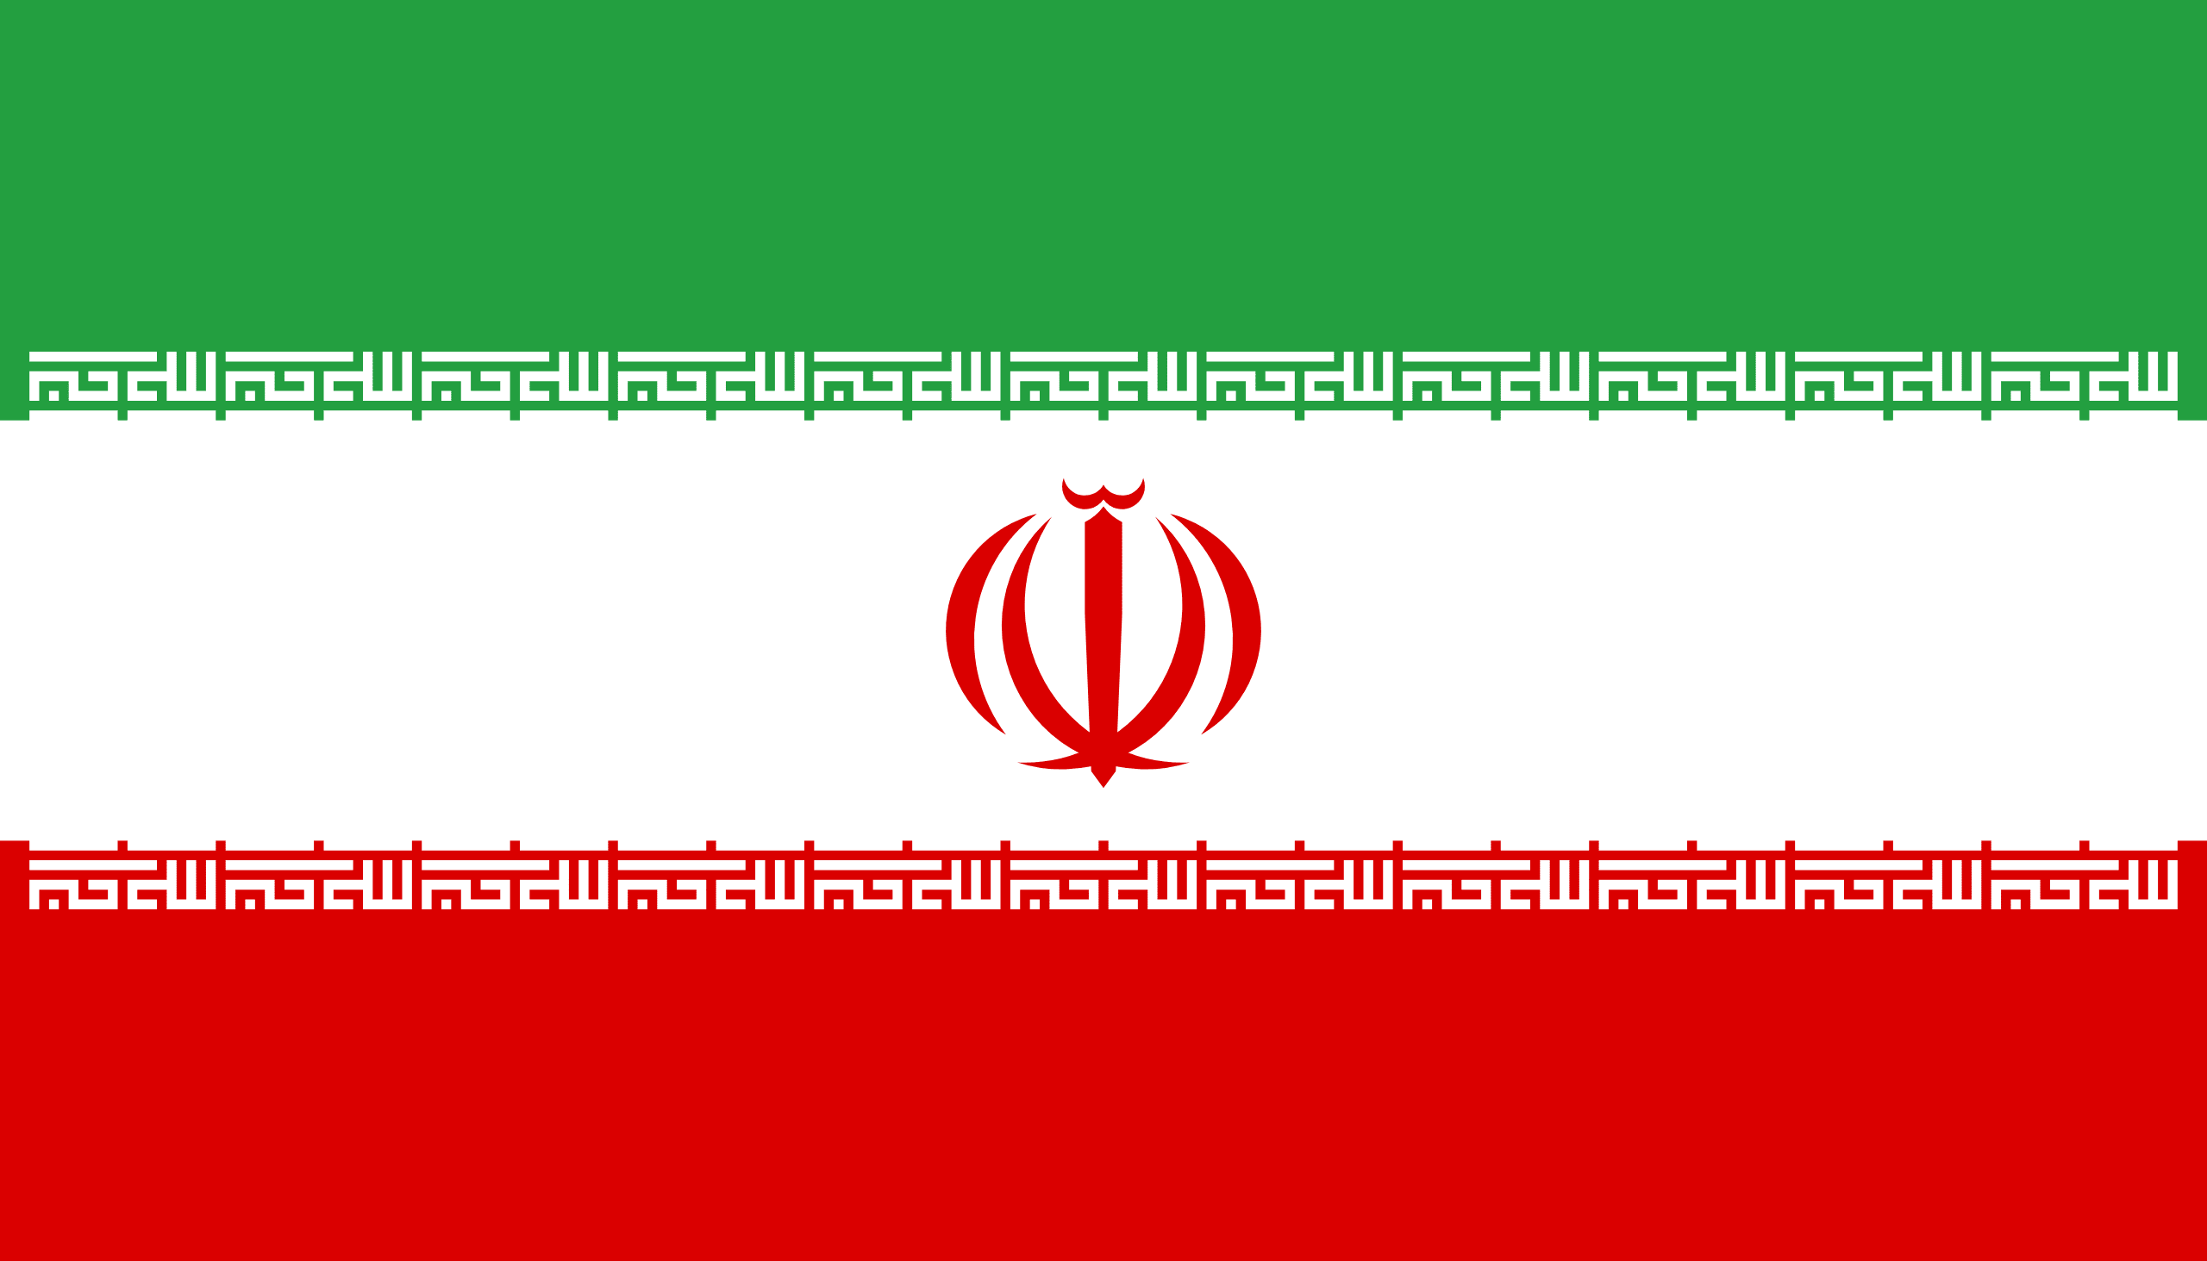
Committee: Israel-Palestine Conflict
Topic: The Republic of Iran’s Position in the Israel- Palestine Conflict
Country: Iran
Delegate: Ece TÜYSÜZOĞLU

The struggle between Israel and Palestine is one of the longest-running and most explosive disputes in the world. For more than 100 years, Jews and Arabs have been fighting in the territory between the Jordan River and the Mediterranean Sea. Neither side is safe as long as the dispute-conflict continues. And dispute will surely lead to serious losses.

The Islamic Republic of Iran is also very concerned about this tension and conflict due to its geographical location. The Republic of Iran considers Israel's actions to be contrary to human rights and believes this kind of violation should be addressed as terrorism. We are always ready to help Palestine financially and spiritually.

We don't accept Israel's invading policy. About 4 million Palestinian refugees have the right to return to their homes. Hard-seized land is not legitimate so we don't consider Jerusalem the capital of Israel.

In the event of any war, The Republic of Iran will also be on the side of Palestine's military. We condemn attacks targeting women and children or mosques. As an Islamic country, we will oppose the expulsion of the Palestinians from their homeland and their lives under violence.

Iran sees the people of both countries as equals, but the persecution of the Palestinians is too great to be tolerated. We know how much the war can cause great losses to the whole world. However, if these actions, which we see as terrorism, continue, Iran will stand with Palestine in the war with all its might

REFERENCES:
https://www.youtube.com/watch?v=GqgiMcaRPaM
https://tr.wikipedia.org/wiki/%C4%B0ran
https://www.bbc.com/turkce/haberler-dunya-57077510
https://www.cia.gov/the-world-factbook/countries/iran/
https://arabcenterdc.org/resource/the-arab-peace-initiative-is-back-on-thetable-netanyahu-is-not-budging/
https://www.youtube.com/watch?v=nERZr_d343w
https://www.bbc.com/turkce/haberler-dunya-60214664
https://en.wikipedia.org/wiki/File:Iran_Palestine_Locator.png
https://www.aa.com.tr/en/middle-east/palestinian-group-says-alliance-with-iran-only-to-resist-israel-/2378078
https://www.reuters.com/world/middle-east/iran-hails-palestinian-victory-warns-deadly-blows-against-israel-2021-05-21/

