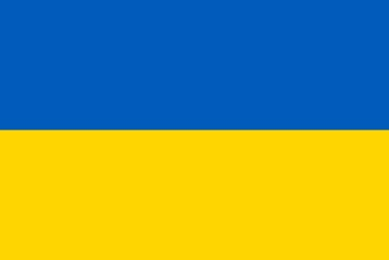
Committee: UNODC (United Nations Office on Drugs and Crime)
Country: Ukraine
Agenda Item: Money Laundering and Countering the Financing of Terrorism
Money laundering is the illegal process of making large amounts of money obtained by criminal activity appear to have come from a legitimate source. An example of the criminal activities mentioned can be drug trafficking, extortion, tax violation, embezzlement, illegal gambling, computer fraud, cybercrimes, unauthorized arms sales and etc.
The rise of online banking institutions, anonymous online payment services, and peer-to-peer (P2P) transfers with mobile phones have made detecting the illegal transfer of money even more difficult. Moreover, the use of proxy servers and anonymizing software makes the third component of money laundering, integration, almost impossible to detect—money can be transferred or withdrawn with little or no trace of an Internet protocol (IP) address. Money also can be laundered through online auctions and sales, gambling websites, and virtual gaming sites, where ill-gotten money is converted into gaming currency, then back into real, usable, and untraceable “clean” money.
Terrorists and terrorist organizations usually need to rely on money to sustain themselves and to carry out terrorist acts. Terrorist financing encompasses the means and methods used by terrorist organizations to finance activities that pose a threat to national and international security. Money provides terrorist organisations with the capacity to carry out terrorist activities, which can be derived from a wide variety of sources. Money can come from both legitimate sources (i.e. profits from businesses and charitable organizations) and criminal sources (i.e. Drug trade, weapon smuggling, kidnapping for ransom).
Money laundering and terrorism financing pose a serious threat to the integrity of the EU economy and financial system and to the security of its citizens.
According to the AML regulations in Ukraine, financial institutions have to apply a risk-oriented approach to customers. The financial institution must investigate information about the customer and analyze the financial transactions of the customers. Firms must report transactions of customers over UAH 150,000. Firms must control financial transactions between the sender and the recipient. The high threat of corruption in Ukraine poses significant commercial risks for foreign investors.
Though the Law of Ukraine “On Preventing and Countering Legalization (Laundering) of Proceeds from Crime, Financing of Terrorism and Financing of Proliferation of Weapons of Mass Destruction” (hereinafter – Law No 361) adopted by the Parliament on 6 December 2019 came into force, money laundering still remains a significant problem in Ukraine.
Corruption is the primary source of laundered funds. Launderers register as ultimate beneficial owners under aliases and integrate laundered money into legal businesses. Ineffective state institutions and an ineffective criminal justice system continue to allow criminal proceeds to go undetected. Although authorities are aware of the seriousness of the problem and are implementing measures to address it, law enforcement rarely targets large-scale corruption related money laundering.
We as the delegation of Ukraine, think that strengthening each countries laws is important. We believe that we must work on countering the new ways of money laundering through virtual currencies and etc.

