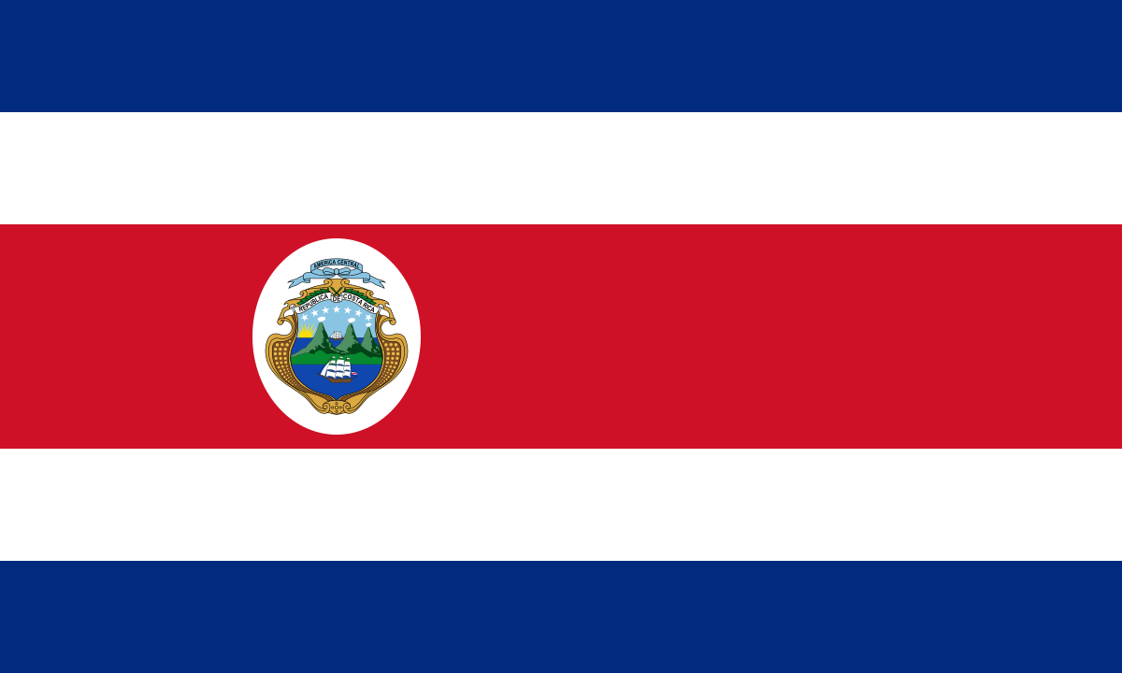
Country: Costa Rica
Committee: United Nations Environment Programme (UNEP)
Topic: Climate Action

Costa Rica, whose capital is San Hose, is a Central American country with a population of over five million. Costa Rica, which is one of the few countries in the world that does not have an army, our country has accelerated the development by abolishing the army and investing this money in the education and health sectors. Also pays attention to the environment and cleanliness and has done and is working on this issue. In addition, despite being such a small and developing country, it sets an example with the measures it takes for countries with very large economies. In addition, Carlos Alvarado, who became the head of the state in 2018, took the cooperation with nature further and increased the hopes that the country will become a much more environmentally friendly country in the future and set an example to the world. These and other factors make it a little easier for us to be the happiest country in the world.

Today, we all have many problems. But not only do we have a problem, our world is also suffering from great difficulties and is receiving serious injuries. So by whom? By humanity to whom it offers its beauties, fertile lands, magnificent waters and priceless natural resources.If we list these troubles, we can count them as follows;
Air, Water and Land Pollution, Global Warming, Climate Change, Deforestation & Logging, Overpopulation, Industrial and Household Waste, Acid Rain, Ozone Layer Depletion, Urban Sprawl, Oil Spill, Natural Resource Depletion, Desertification, Habitat Loss and Destruction, Loss of Biodiversity, Water Shortage.

So what have we, as humanity, done to prevent these harms? In January, more than 50 countries committed to the protection of 30% of the planet’s land and oceans as part of the High Ambition Coalition (HAC) for Nature and People, spearheaded by Costa Rica, which is a co-chair alongside France and England. In 2015 Paris agreement was adopted and entered into force 2016. It is considered a landmark as it showed a course of efforts on combating climate change, and it is the first binding agreement that brought all nations under one agreement. Paris Agreement was signed by 195 nations.The United States of America signed later in 2016, enabling the agreement to take effect by reaching the representative level of 55% of global emissions as the ratifying countries, which without the agreement does not take effect. In 2017, the United States of America had a formal withdrawal from the Paris agreement. The withdrawal terminated $3 billion U.S. dollars of funding.

So what have we done to put a stop to climate change? The current and previous administration has made many efforts against global warming on behalf of Costa Rica. Carlos Alvarado Quesada has meticulously continued these works since he came to the management in 2018. As he said, we have big projects for the future. President Alvarado Quesada has initiated a series of policies to reduce Costa Rica’s carbon emissions and promote the country’s environmental and social policies beyond its borders. This year, Costa Rica was named a winner of the ‘Earthshot Prize’ for protecting nature. Its green initiatives have doubled the number of trees and is seen as a role model for others to follow. Ninety-nine percent of Costa Rica's energy is renewable energy. We are aiming for total decarbonisation by 2050, not just a “net zero” target. We has regrown large areas of tropical rainforest after suffering some of the highest rates of deforestation in the world in the 1970s and 1980s. Costa Ricans play a major role in international environmental politics, most notably Christiana Figueres, who helped to corral world leaders into agreeing the Paris accord. According to the National Meteorological Institute, transportation today accounts for about 40% of Costa Rica's emissions. The new plan aims to modernize public transportation, including the creation of an electric train line that will connect fifteen of the thirty-one neighborhoods in the San José metropolitan area, according to the Costa Rican Railroad Institute. Work on the lines is expected to start in 2022. It also aims to halve the number of cars in urban areas by 2040. Rodríguez states that by 2035, 70% of the country's buses and 25% of its cars will be electric. Here we, as Costa Rica, have done small and large works like these and these. We urge all other countries to do something urgently to curb climate change as much as their economy can afford.

What should we put on top of what we've done or what should we do as new projects? We, as Costa Rica, recommend that all other countries apply the system we apply to the best of their ability. We recommend switching to purely electric vehicles instead of diesel and gasoline vehicles, collecting a common amount of money by donating a certain level according to the economy of each country, and making stations for electric vehicles and aiding the production of electric vehicles to countries with bad economy. In addition, we recommend using renewable energy sources instead of energy sources that harm nature such as fossil fuels and nuclear energy. Of course, we are completely open to innovative and logical ideas.

In fact, important agreements and studies have been made for climate change with the great support of the European Union. But of course, this is still developing, and no matter how careful we are while developing, it is a bit insufficient because we pollute the nature. All of us, as a whole humanity, are at war with nature, if we win, we will lose everything, but if we lose, we will win our future. Please be conscious and think about our future.

